LAb 07

Terminal 1

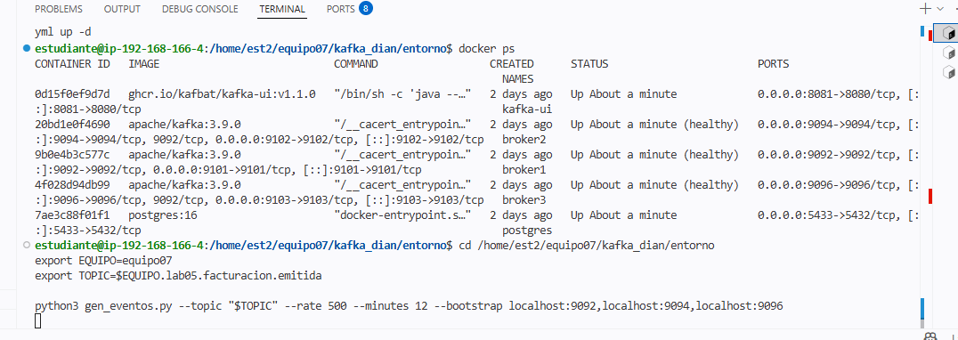
Terminal 2
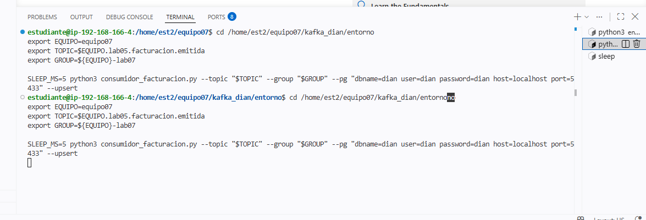

Terminal 3
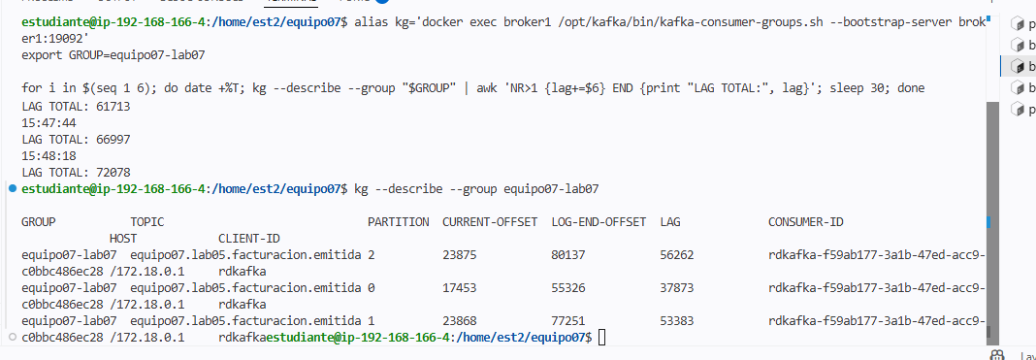
Terminal 4
Terminal 5
Terminal 6
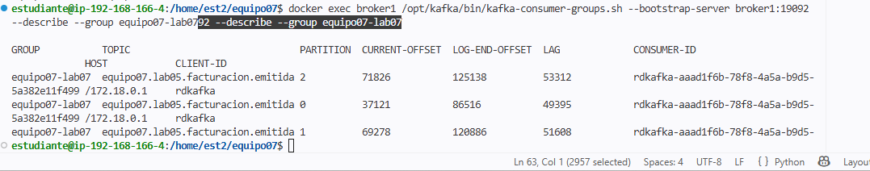

Terminal 7


